80th Anniversary of D-Day Programme
All events are Free and open to all unless stated otherwise BELOW
PAY FOR QUIZ Weds 5th June 7-9pm Quiz –Yacht Club, Overgang (£4 person)
PAY BREAKFAST- Thurs 6th June -9-1030 am D-Day Breakfast in `Vigilance` PH
PEOPLE ARE ENCOURAGED TO DRESS UP IN 1940`S STYLE & PARTICIPATE IN ALL EVENTS
Tuesday 4th June 2024
FREE-1030am -230pm D-Day Exhibition in Brixham Museum -New Road
FREE-1030am- 5pm Middle and Fore Street Shop window displays
FREE-1030am -5pm Activities at the Quayside, Fore and Middle St.
FREE- 730pm - 9pm Social event at Brixham Museum in New Road
Entertainment from South Devon Players 8pm -820pm
Weds 5th June
FREE -1030am -230pm Brixham Museum D-Day Exhibition -New Rd
FREE-1030am- 5pm Middle and Fore Street Shop window displays
FREE-2pm -------4pm Brixham Battery, Open to Public-Fishcombe Road
FREE-1030am - 5pm Activities at the Quayside, Fore and Middle St.
FREE-730pm -930pm Shoalstone Pool Green Events -Berry Head Road
730PM -8PM Community Singalong with Jane Anderson Brown
8PM-9PM musical entertainment with Leandre Duo
730pm-9pm 1940`s Quiz at Brixham Yacht Club ( Fee £4 pp)
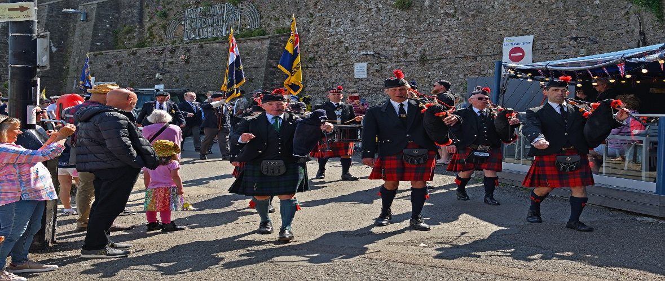
Scottish Pipers & Drums will lead our 1030AM Parade from `Man & Boy ` Statue -South Quay to
Breakwater Beach for commemoration service and entertainment. Photo Chris Slack.
Thursday 6th June
830am -10am D-Day paying Breakfast in `Vigilance ` Bolton st
930am -10am Missin`tackle Shanty Crew
FREE- 1030am 230pm Brixham Museum D-Day Exhibition -New Rd
FREE-1030am- 5pm Middle and Fore Street Shop window displays FREE-1030am -5pm Activities at the Quayside, Fore and Middle St.
Main Event -FREE -D-Day Commemoration and Celebration Parade
930am Visit of Lord Lieutenant Embarkation Mural in Berry Head Rd
1030am Parade assembles at `Man & Boy ` Statue to Breakwater
1050 am Parade arrives led by Standard Bearers and Scottish Pipers
11am Formal Commemoration service and wreath laying begins
Music from Town Band and Brixham Orpheus Male Voice Choir
12-1230pm Community sing-a-long at Breakwater Beach with Jane Anderson Brown
1230pm-1pm Music from Plymouth Scottish Pipers and Drummers Band
2pm-5pm Film `The Longest Day ` -Conservative Club-New Rd
1pm -Lord Lieutenant`s invited only guest`s lunch at Berry Head Hotel.
630pm -7pm Bell ringing in local churches to mark historic event
7pm-1130pm `Run Ashore` event in Conservative Club-New Road.
9pm -930pm BTC Beacon Lighting at Shoalstone Green-Berry Head Rd
Friday 7th June
FREE-1030am -230pm Museum D-Day Exhibition -New Rd
FREE-1030am- 5pm Middle and Fore Street Shop window displays
FREE-1030am -5pm Activities at the Quayside, Fore and Middle St.
FREE-1pm- 2pm Sandy Sparkle- Prince William Sq South Quay
FREE-2pm -245 pm Missin`tackle Shanty Crew Prince William Sq
FREE-2pm -5pm Film `Saving Private Ryan`-Conservative Club
FREE- 2pm -4pm Brixham Battery Museum open (Fishcombe Rd)
FREE-230 pm -330pm -1940`s Concert Methodist Church, Fore Street
Saturday 8th June
FREE-1030am -130pm Brixham Museum D-Day Exhibition -New Road
FREE-1030am- 5pm Middle and Fore Street Shop window displays
FREE-1030am -5pm Activities at the Quayside, Fore and Middle St.
FREE-1pm -2pm Segals -Fore St- Outside Tesco` Fore St.
FREE-230-330pm Baptist Church Brewery Lane -Sandy Sparkle 1940`s
music concert and sing-a-long.
FREE-Sat 8th June 1030-4pm D-Day Boats in Conservative Club, New Rd
FREE-Sat 8th June 7pm -12pm Dancing in the Conservative Club -New Road
Sunday 9th June
FREE-1pm -2pm Seagals Fore St-Outside Tesco`s
FREE 11am to 4pm Brixham Battery open for special D-Day event
FREE 1030am to 4pm D-Day Model Boat exhits -Conservative Club New Rd
FREE-2pm-3pm Torbay Brass Band -Prince Willian Sq
FREE-3pm-345pm Mike Holgate -Prince William Sq
FREE-7pm- 8pm St. Mary`s Church commemoration in presence of
the Lord Lieutenant representing HM King.
Brixham Town Band and Brixham Orpheus Male Voice Choir
7pm-745 Commemoration then Community Singing to 815pm
8 15pm -9pm Tea /coffee reception at adjacent Church Centre
FREE Major Films in Brixhm ALL IN THE CONSERVATIVE CLUB -New Rd.
Thurs -6TH JUNE -2PM-5PM `The Longest Day`
Fri -7TH JUNE -2PM -5PM ` Saving Private Ryan`

